**APP DEV PROJECT**

**Kainath Ahmed, Zachary Dubé, Kyle Fournier**



**Team composition:**

* Kainath: Frontend (Components specifically, certain screens), Backend (Kotlin/Compose), Database (Room)
* Zach: Frontend, AI, Database, Backend (Kotlin)
* Kyle: AI, Backend (Kotlin)

**Application name/logo**: MealMind, logo is above

**Description:**

* An app that uses AI to recommend recipes and meal plans based on dietary preferences, ingredients on hand, budget and nutritional goals. It gives us personalized recipe suggestions helping with mental health focusing on food health.
* Uses an API or we create a model using a meal planning dataset
* Possible API’s; [MealMe](https://www.mealme.ai/?utm_source=google&utm_medium=google+search&utm_campaign=Search+ads+for+conversations&gad_source=1&gclid=CjwKCAiAxKy5BhBbEiwAYiW--z5zspQE39qW5-nhF0paqnsuc_Q14EiECWPGGuBUX00XSA7JCE7GgxoCGyUQAvD_BwE), [Edaman](https://developer.edamam.com/edamam-docs-recipe-api)
* Possible Datasets; [Food.com](https://www.kaggle.com/datasets/shuyangli94/food-com-recipes-and-user-interactions)
* Uses MVVM architecture pattern.

**Application Scope:**

* **Screens:** profile screen, recipes, form, recipe details, home screen, register user, login
* **Profile screen:** Name, email address, recipe history button and preference form button, maybe a photo that a user can add.
* **Recipes:** The recipes that are generated from the preferences the user chose. A button going back to the form screen to restart it if you want.
* **Form:** A type of quiz to display your dietary preferences, ingredients you already have, budget if you want to add more ingredients and nutritional goals.
* **Recipe Details:** Gives overview on the recipe and gives you instructions and ingredients. Also has a back button to go back to the recipe list.
* **Home:** The main screen when the user first starts registering by pressing the GET STARTED button.
* **Register User:** Register the user with name, email address and password (to be able to save user data and their preferences, connect their recipes to them)
* **Login:** Login page to go profile screen or recipe screen, login with username and password
* **Navigation:**

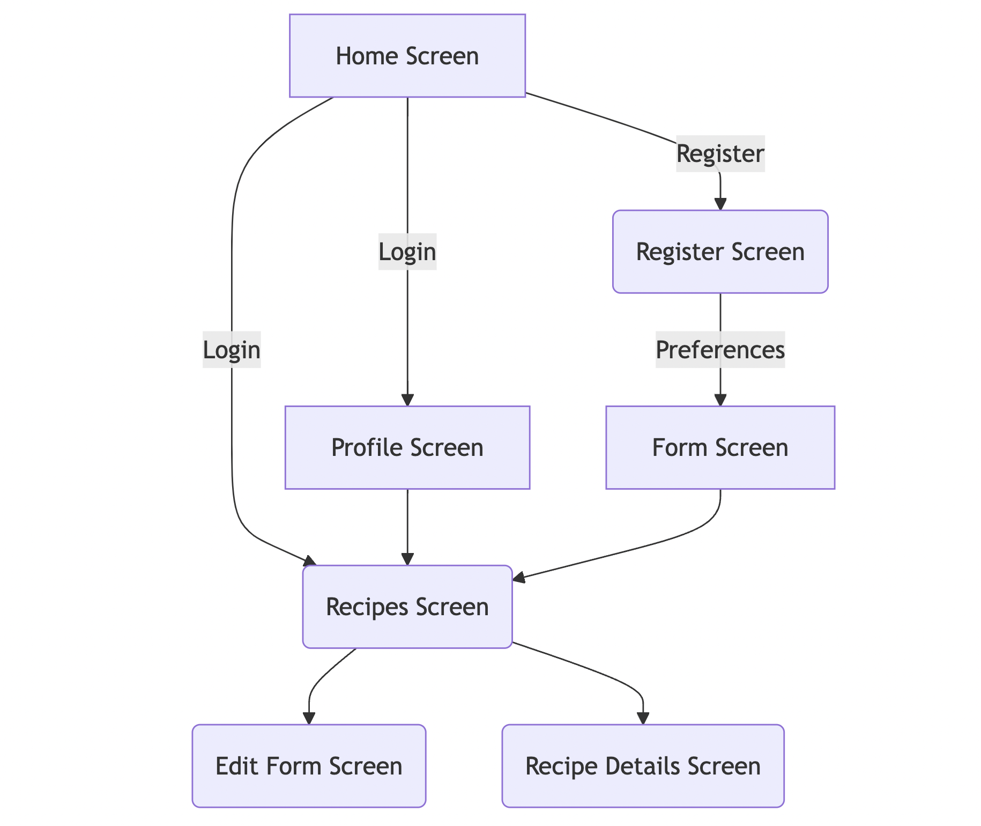

* **Potential database we are using:** Room (Jetpack Library)

**Database Tables:**

* Recipe (possibly using an API or dataset, ingredients, instructions, totaltime, servings)
* Users (Username, password, email, preferences)

